User Guide — Office 365 Connector

Overview
The Office 365 Connector is an MCP (Model Context Protocol) connection that allows the TÀI AI assistant to access your Microsoft 365 directly — including Outlook Mail, Outlook Calendar, and Microsoft Teams — right within the TÀI Studio chat interface.
Key differentiators of the Office 365 Connector:
- Quick access: read emails, calendar events, and Teams messages without leaving TÀI Studio.
- Personal security: always operates under your own account and permissions — no shared or admin accounts are used.
- Read-only (MVP 1): currently supports viewing information only, cannot send emails or create events — ensuring complete safety.
──────────────────────────────────────────────────

Activation & Login
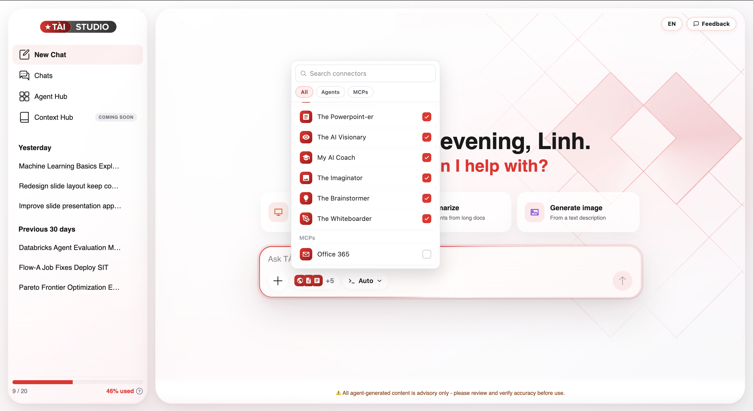
To use the Office 365 Connector, you need to activate it in TÀI Studio:
- In the message input area, click the "+" button (bottom-left corner).
- The "Search connectors" popup appears with tabs: All, Agents, and MCPs.
- Under the MCPs section, check Office 365.
Note: Agents (The Powerpoint-er, My AI Coach, The Imaginator…) and MCPs are two separate types of connectors. Office 365 is in the MCPs group.
──────────────────────────────────────────────────

Automatic Authentication
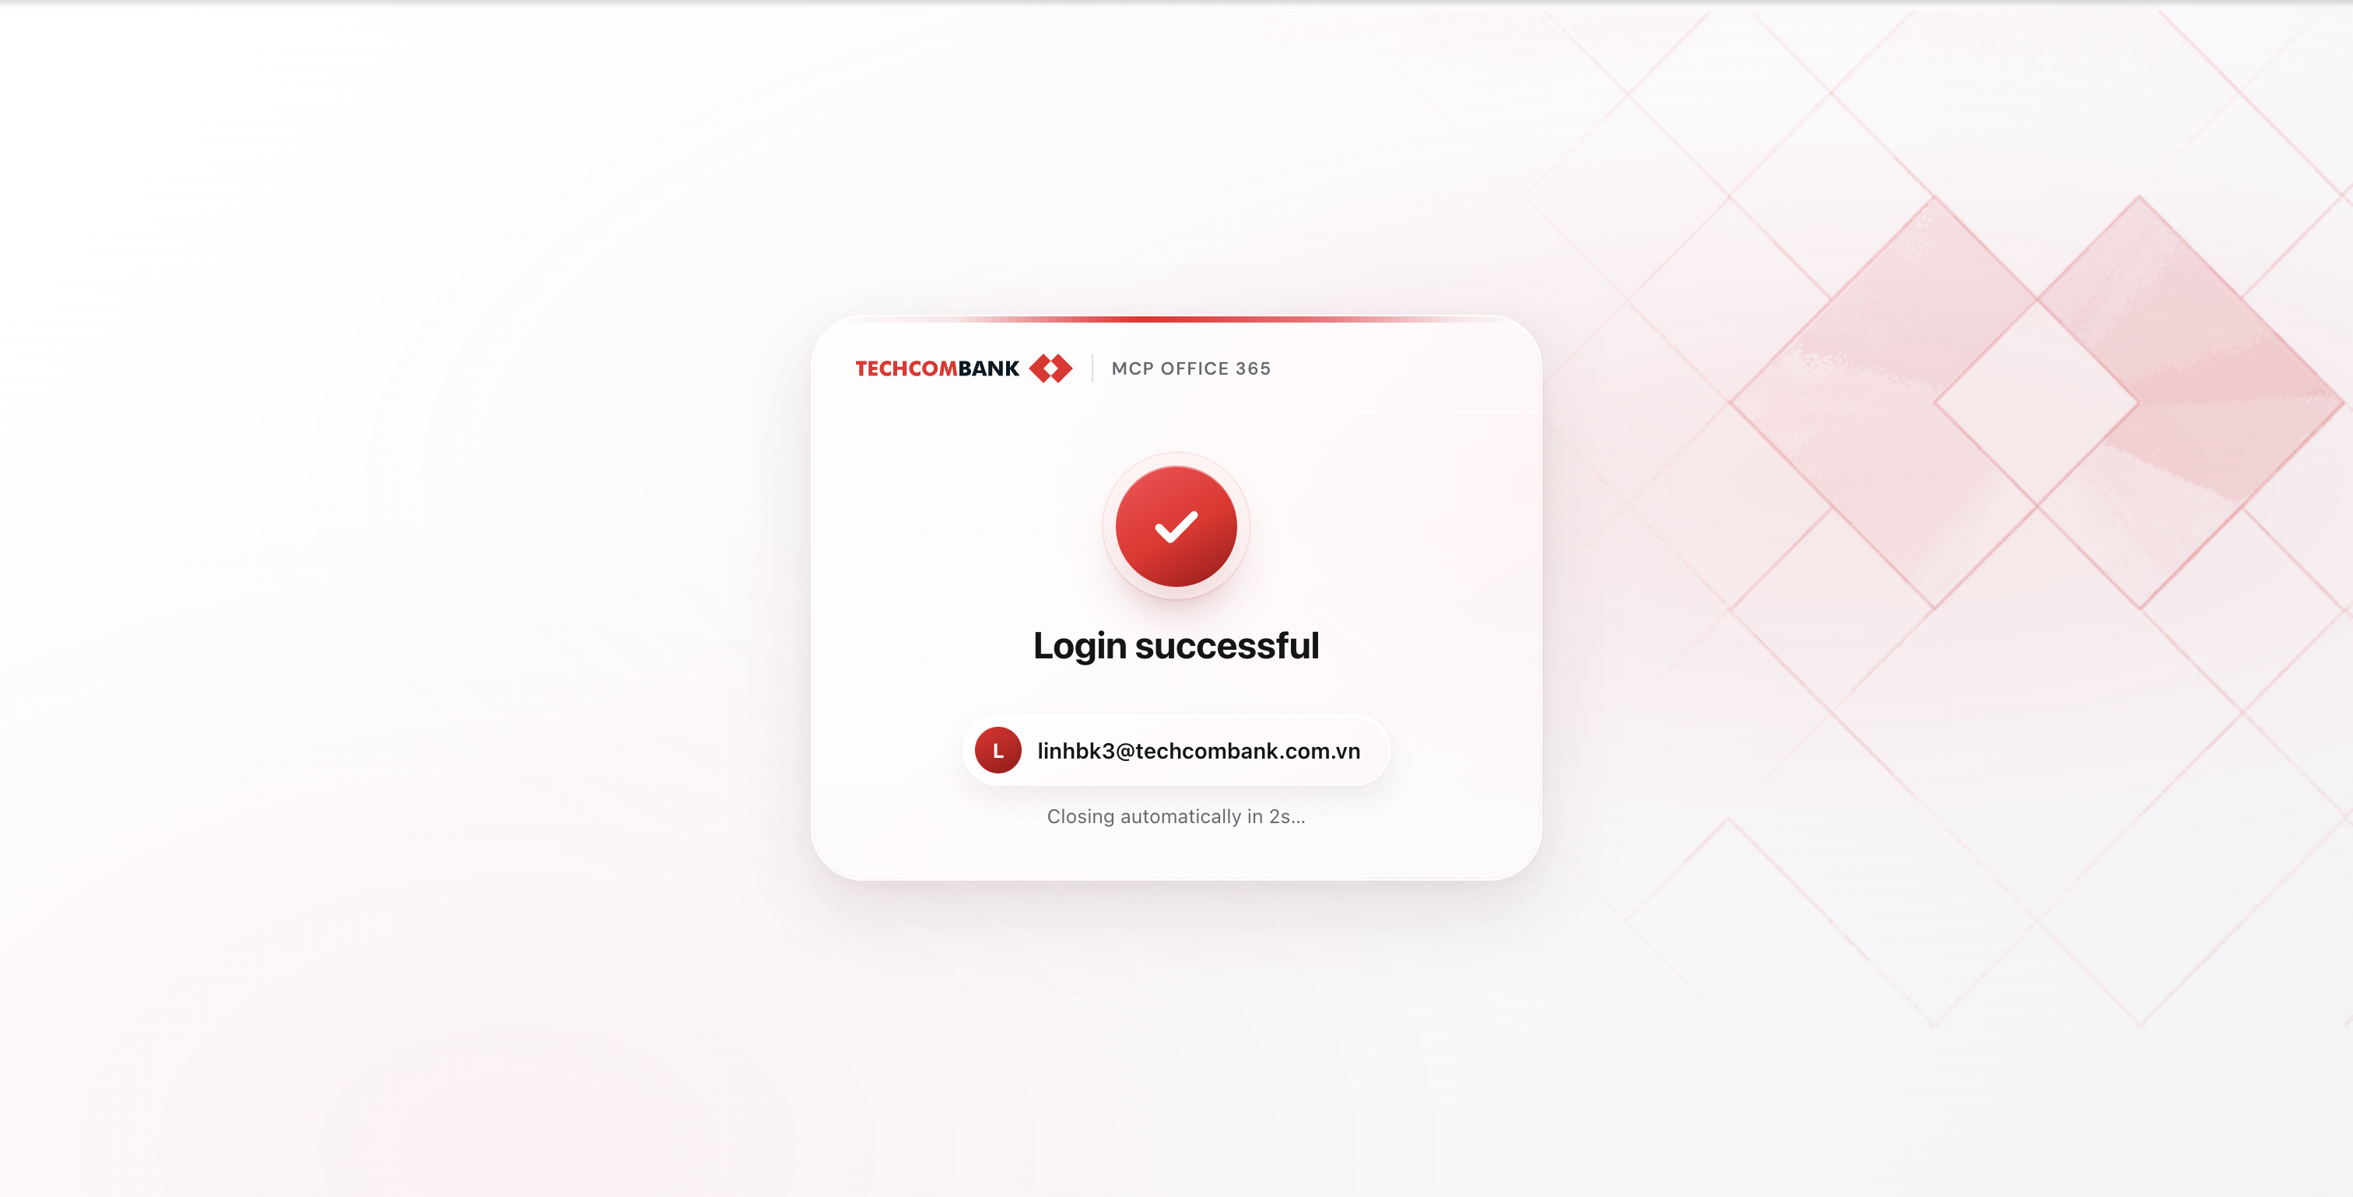
As soon as you check Office 365, the system will automatically authenticate your Microsoft 365 account:
- After selecting Office 365 in the connector popup, the system automatically connects to your Techcombank account (@techcombank.com.vn).
- The screen displays a "Login successful" message along with the authenticated account email.
- The popup closes automatically after 2 seconds — you can start using it immediately.
No password entry or login links required — the process is fully automatic based on your current login session.
Session duration:
- Access token auto-refreshes within 1 hour.
- Total session lasts 7 days — after that, you need to reactivate the connector to re-authenticate.
──────────────────────────────────────────────────

Main Features
The Office 365 Connector supports 3 feature groups: Mail, Calendar, and Teams.

Outlook Mail — Read Emails
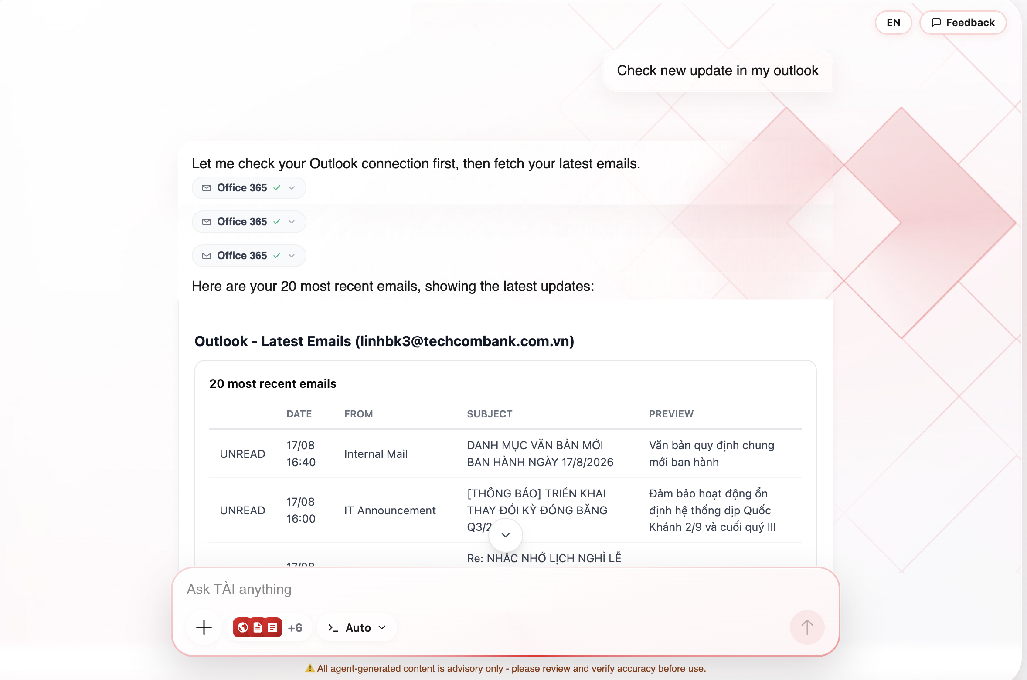
You can ask TÀI to:
Request | Example prompt
View latest emails | "List my 5 most recent emails"
Find emails by sender | "Find emails from nguyenva@techcombank.com.vn"
Find emails by subject | "Find emails with subject containing 'meeting'"
Read email details | "Read the details of the first email in the list"
View emails with attachments | "Find emails with attachments"
View emails in folder | "List emails in the drafts folder"
Information displayed:
- Email list: date received, sender, subject, read/unread status, content preview (200 characters).
- Email details: full content, recipient list (to, cc), attachment information.
Note: Cannot download attachment content — only the name, type, and size are visible.
──────────────────────────────────────────────────

Outlook Calendar — View Meetings
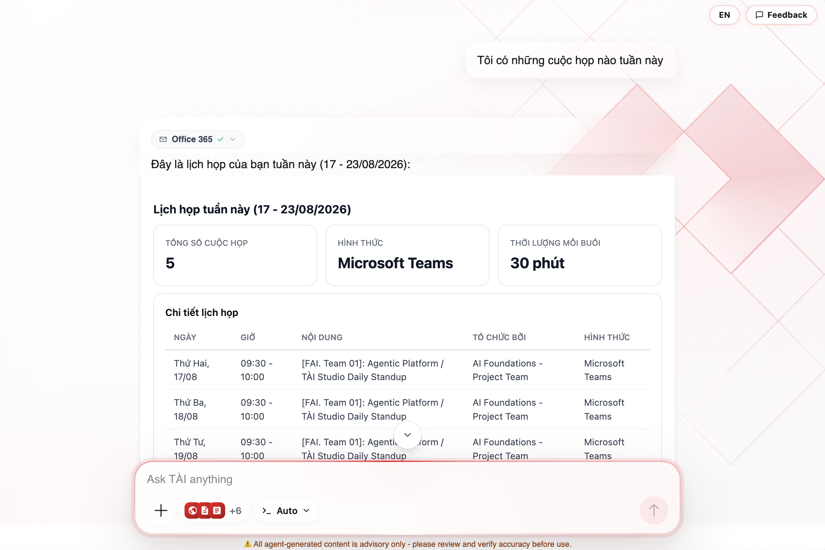
You can ask TÀI to:
Request | Example prompt
View upcoming meetings | "What meetings do I have this week?"
View meeting details | "Details of the first meeting in the list"
Find free time slots | "Find 2 free hours tomorrow"
View calendar list | "What calendars do I have?"
Information displayed:
- Meeting list: title, start/end time, location, organizer, meeting type (online/offline).
- Meeting details: attendee list, agenda, join link (for online meetings).
- Free time search: available time slots with suggested notes.
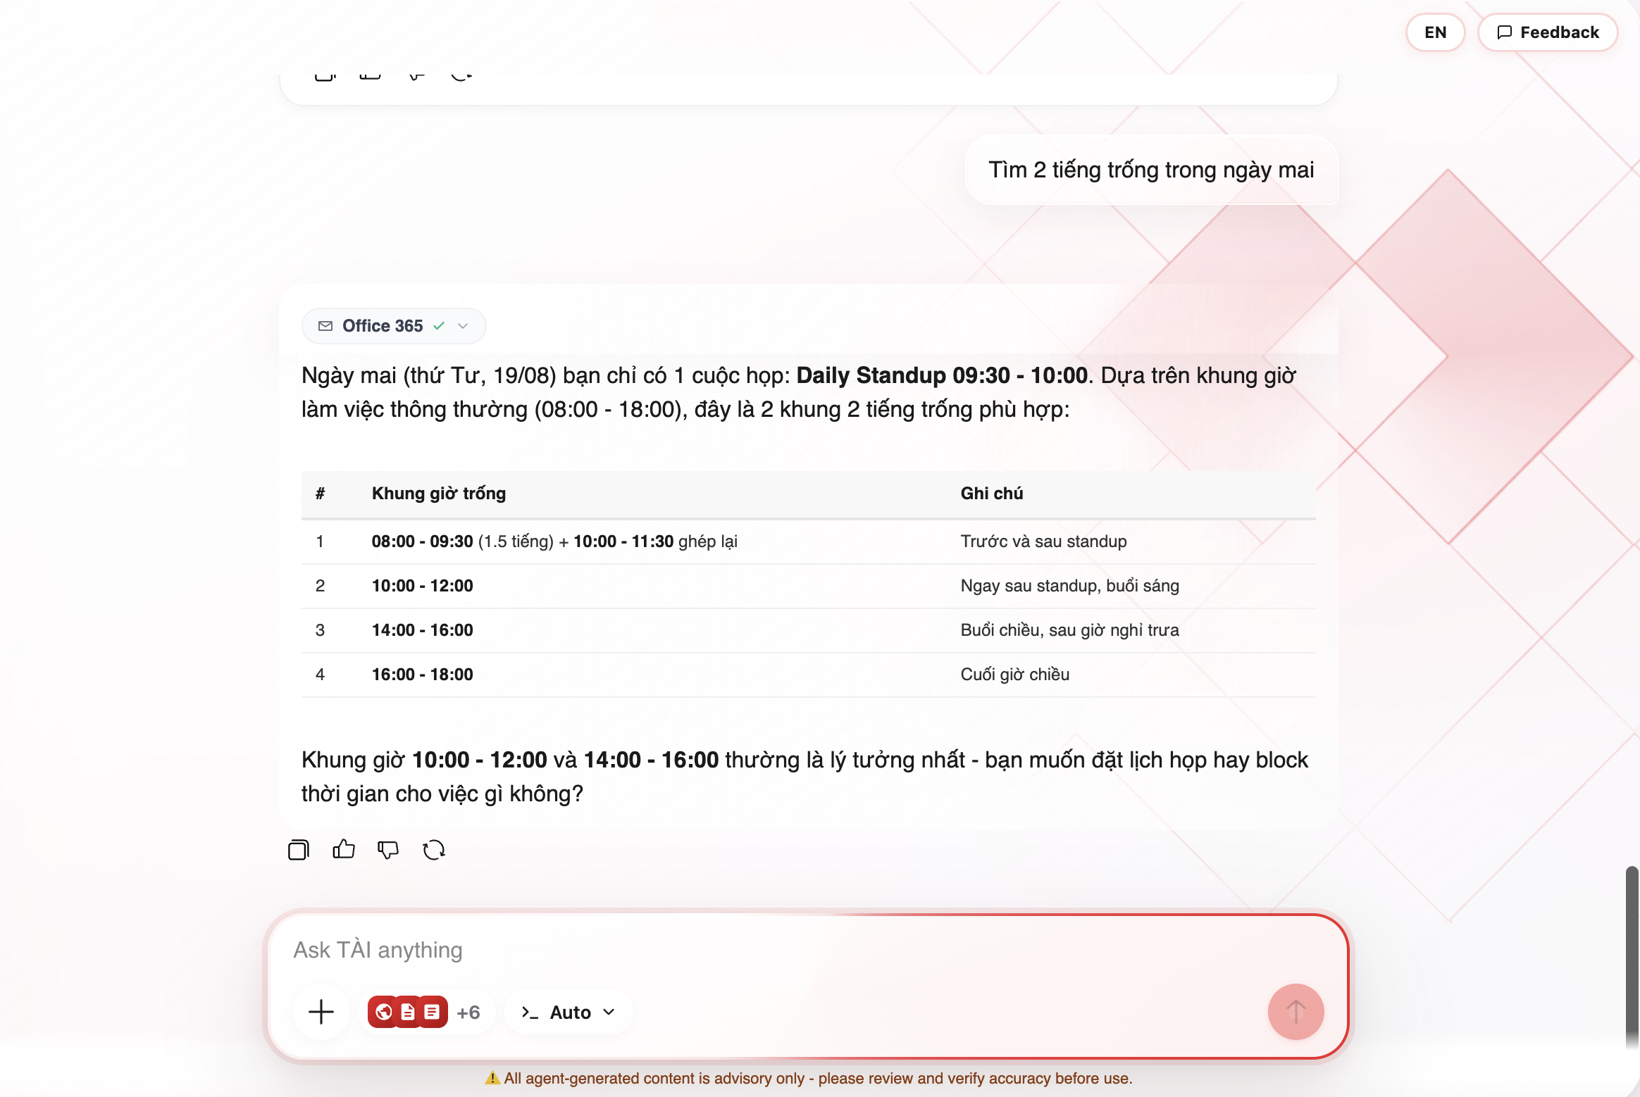
Note: Free time search only provides suggestions — it does not automatically schedule meetings. Results are displayed in Vietnam time (Asia/Ho_Chi_Minh).
──────────────────────────────────────────────────

Microsoft Teams — Read Messages
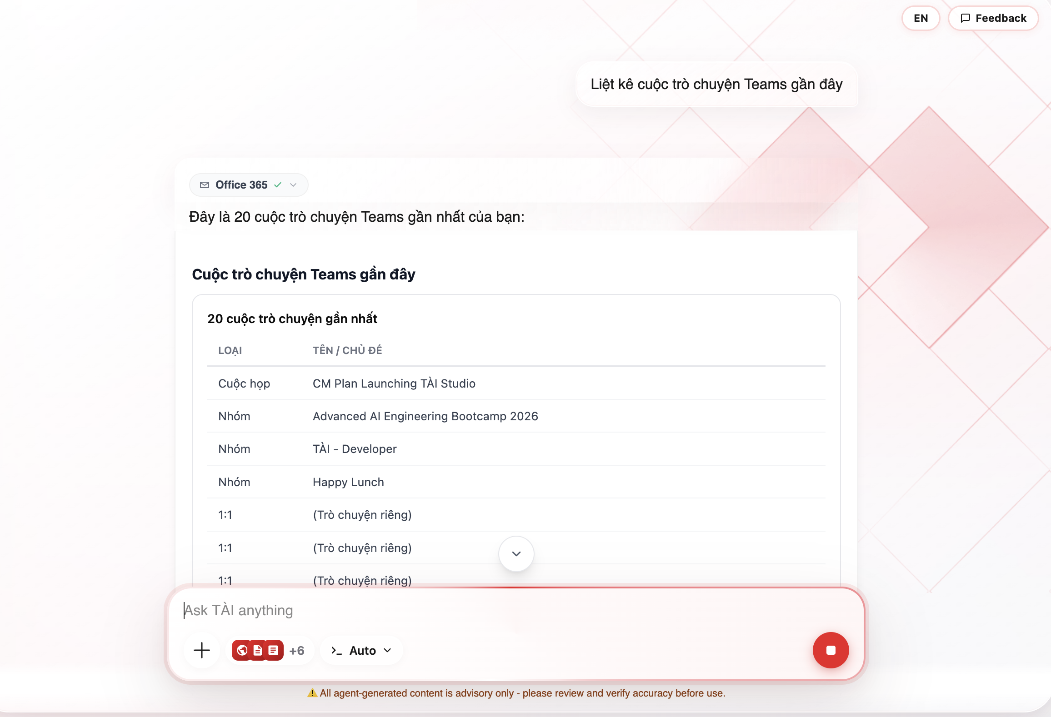
You can ask TÀI to:
Request | Example prompt
View team list | "What teams am I part of?"
View channels in a team | "What channels does team XYZ have?"
Read channel messages | "Read the 5 latest messages in the General channel"
View conversations | "List recent Teams conversations"
Read chat messages | "Read messages in the first conversation"
Information displayed:
- Conversation list: type (Meeting / Group / 1:1) and name/topic.
- Messages: sender, time, content (truncated at 200 characters).
Note: 1-on-1 chats often do not display participant names — TÀI will indicate when it cannot determine who the conversation is with.
──────────────────────────────────────────────────

Search Colleagues
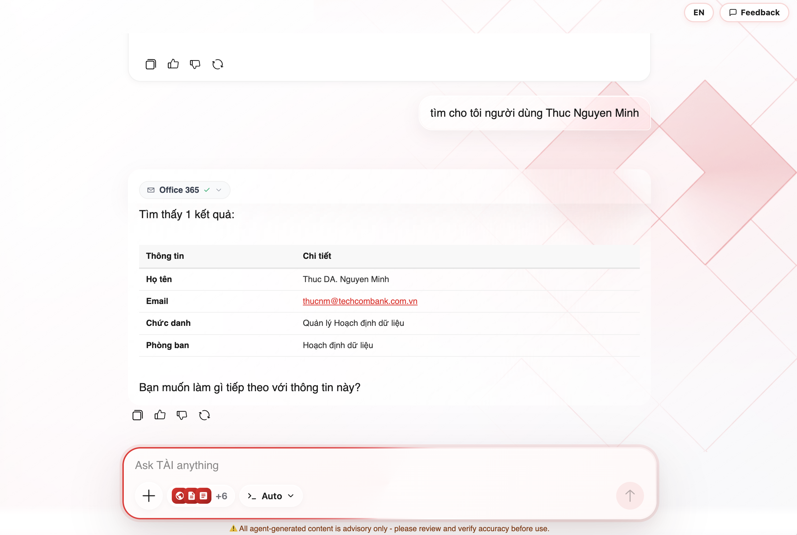
You can ask TÀI to find colleague information by name:
Request | Example prompt
Find colleague information | "Find user Thuc Nguyen Minh"
Information displayed:
- Full name, email, job title, department.
- If multiple results match, TÀI will ask you to select the correct person.
- If no results found, try searching with a single word from the name (first or last name only).
Note: Only people you have previously interacted with can be found — not the entire company directory.
──────────────────────────────────────────────────

Logging Out of Office 365
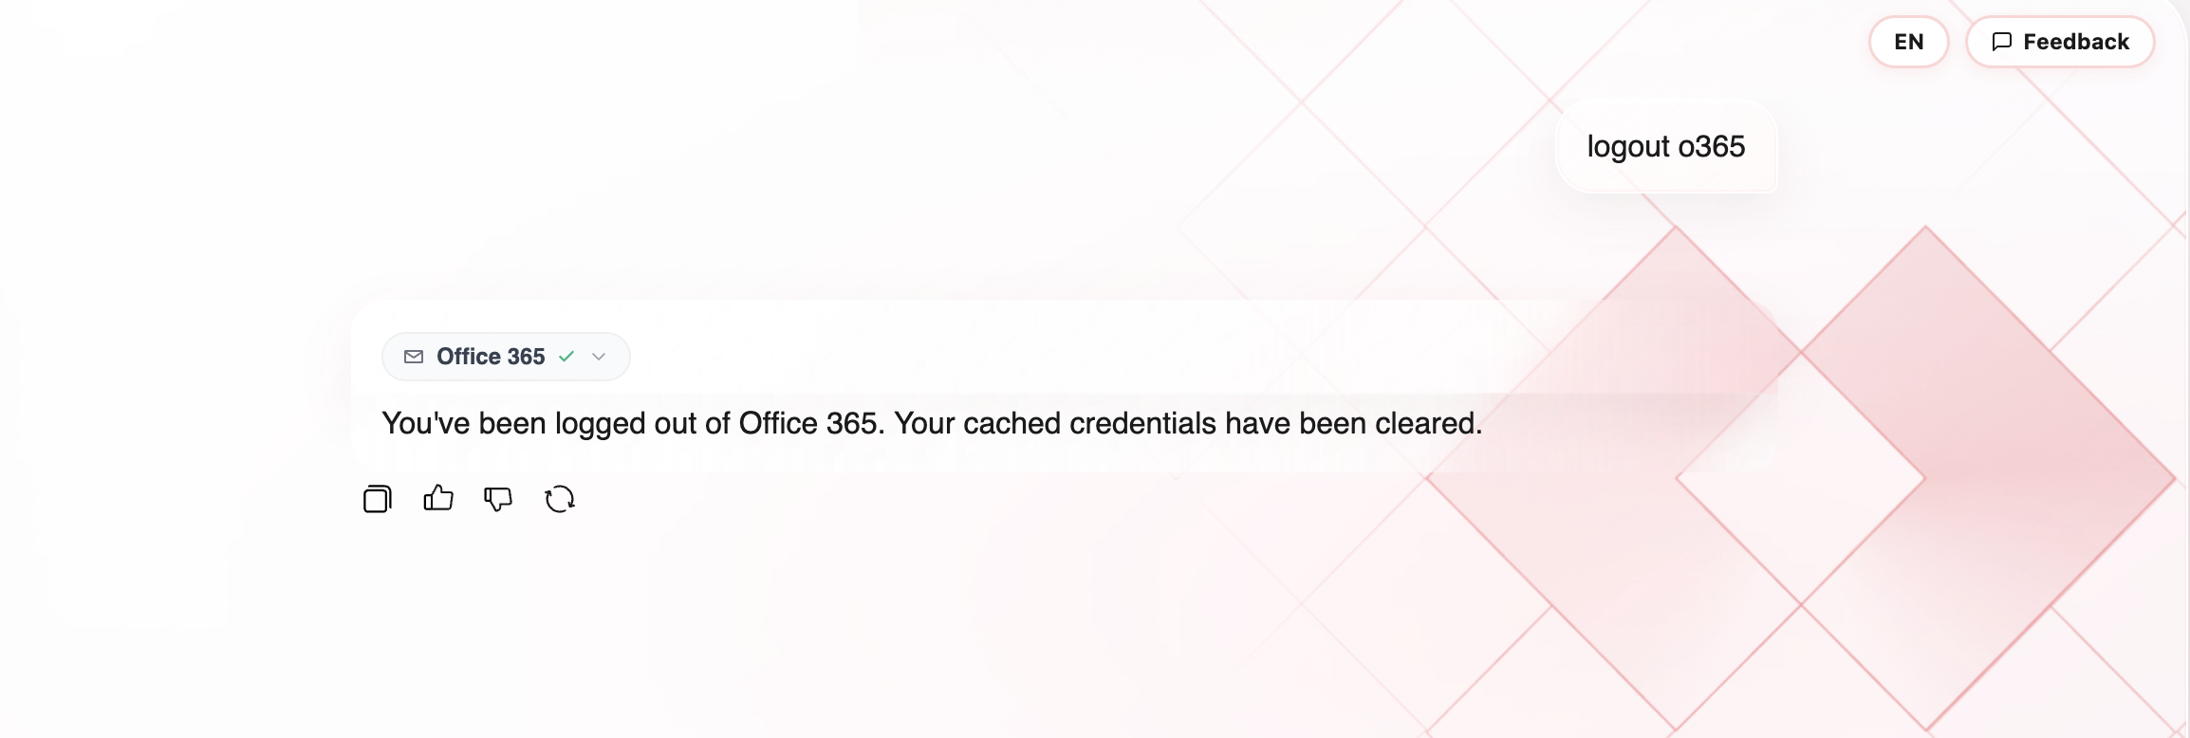
When you want to disconnect Office 365 from TÀI Studio:
- Type "logout o365" (or similar commands like "log out of Office 365") in the chat input.
- TÀI will perform the logout and confirm: "You've been logged out of Office 365. Your cached credentials have been cleared."
When to log out:
- When you want to stop TÀI from accessing your Microsoft 365.
- When you want to switch to a different account.
- For security reasons — for example, when using a shared device.
After logging out, you need to reactivate the Office 365 connector (check it again in the "+" popup) to authenticate and continue using it.
──────────────────────────────────────────────────

How TÀI Processes Office 365 Requests
When you send a question related to Office 365, TÀI performs these steps:
- Check connection — confirm the session is still valid.
- Select the appropriate tool — automatically choose the right tool based on your question (e.g., list_mail_messages, get_calendar_view).
- Call Microsoft Graph API — query data from your Microsoft 365.
- Present results — display information in an easy-to-read table or list format.
You may see an "Office 365 ✓" label in the response — this confirms TÀI successfully used the connector.
──────────────────────────────────────────────────

Security & Access
The Office 365 Connector is designed with multiple security layers:
Security Layer | Details
Automatic authentication | Identity verified via SSO — no password re-entry needed
Permissions | Uses only your own permissions (delegated) — no admin access
Read-only | MVP 1 supports reading only — cannot send emails, create/edit/delete meetings
Encryption | Tokens encrypted with AES-256-GCM, isolated per user
No content storage | Email/chat content is not stored — Microsoft 365 is the sole source
Proactive logout | Users can logout at any time to clear cached credentials
Audit | Every tool call generates an audit log entry
──────────────────────────────────────────────────

Tips
- Be as specific as possible — "List my 5 latest emails" gets faster results than "Check my mail".
- Specify quantities when needed (e.g., "5 emails", "3 meetings this week").
- Specify time ranges when asking about calendar (e.g., "from 18/08 to 22/08/2026").
- Use real names when searching for colleagues — full email address is not required.
- When TÀI asks for clarification (e.g., "Whose email do you mean?"), reply specifically — TÀI does not guess.
- Combine multiple requests in one message (e.g., "Check new emails and tomorrow's meetings").
- Type "logout o365" when you want to disconnect.
──────────────────────────────────────────────────

Limitations
Limitation | Details
Read-only | Cannot send emails, create/edit/delete meetings, or send Teams messages
No attachment download | Only name, type, and size of attachments are visible — content cannot be downloaded
No transcript viewing | Meeting transcript reading is not yet enabled
Limited preview | Email and message content in lists is truncated at 200 characters — request details for full content
Limited people search | Only finds people you have previously interacted with, not the entire directory
Session expiry | After 7 days, you need to reactivate the connector to re-authenticate
Incomplete results | If TÀI says "hasMore: true", there is more data available — you can ask to see more
──────────────────────────────────────────────────
This guide applies to the Office 365 Connector (MVP 1 — read-only).
⚠️ Responses may not always be accurate — please verify important information.
──────────────────────────────────────────────────
Last updated: 18/08/2026

